Practical no: 8

Aim: Bayesian theorem
a. Implement Bayesian Learning using inferences.
Description:
Bayesian Learning using inferences means using Bayes' Theorem to learn from data by updating your belief about something unknown each time you observe new information.
It is a method of probabilistic learning where:
You start with an initial belief (called the prior)
You collect data or evidence (observations)
You update your belief (now called the posterior) using Bayesian inference
Bayes' Theorem (Simplified):
Posterior=Likelihood × Prior
Evidence
Where:
Prior is what you believe before seeing any data.
Likelihood is how well the data supports different beliefs.
Posterior is your updated belief after seeing the data.
Evidence is a normalizing constant to ensure probabilities add up to 1.
What It Means in Practice:
Imagine you're trying to figure out something uncertain — for example:
Is a coin fair?
Is an email spam?
Is a patient likely to have a disease?
You begin with a guess (the prior), observe some results (like coin flips or emails), and then you update your belief based on what you observed. That updated belief is the posterior.
This update process is called Bayesian inference.

Code:
import pandas as pd
import numpy as np
import matplotlib.pyplot as plt
import seaborn as sns
from datetime import datetime

from sklearn.model_selection import train_test_split
from sklearn.preprocessing import OrdinalEncoder
from sklearn.compose import ColumnTransformer
from sklearn.pipeline import Pipeline
from sklearn.naive_bayes import GaussianNB
from sklearn.metrics import accuracy_score, confusion_matrix, classification_report

# -----------------------------
# Load data
# -----------------------------
PATH = "healthcare_dataset.csv"
df = pd.read_csv(PATH)

# Parse dates
for col in ["Date of Admission", "Discharge Date"]:
if col in df.columns:
df[col] = pd.to_datetime(df[col], errors="coerce")

# Feature engineering
if {"Date of Admission", "Discharge Date"}.issubset(df.columns):
df["length_of_stay"] = (df["Discharge Date"] - df["Date of Admission"]).dt.days
if "Date of Admission" in df.columns:
df["admit_month"] = df["Date of Admission"].dt.month
df["admit_weekday"] = df["Date of Admission"].dt.weekday

TARGET = "Test Results"
df = df.dropna(subset=[TARGET]).copy()

candidate_features = [
"Age","Gender","Blood Type","Medical Condition","Insurance Provider",
"Billing Amount","Admission Type","Medication","length_of_stay",
"admit_month","admit_weekday"
]
features = [c for c in candidate_features if c in df.columns]

X = df[features].copy()
y = df[TARGET].astype(str)

# Train/Test split
X_train, X_test, y_train, y_test = train_test_split(
X, y, test_size=0.2, random_state=42, stratify=y
)

# Preprocessing
numeric_cols = [c for c in features if pd.api.types.is_numeric_dtype(X_train[c])]
categorical_cols = [c for c in features if c not in numeric_cols]
cat_encoder = OrdinalEncoder(handle_unknown="use_encoded_value", unknown_value=-1)
preprocess = ColumnTransformer([
("num", "passthrough", numeric_cols),
("cat", cat_encoder, categorical_cols)
])

# Model
pipe = Pipeline(steps=[("prep", preprocess), ("nb", GaussianNB())])
pipe.fit(X_train, y_train)

# Predictions
y_pred = pipe.predict(X_test)
y_proba = pipe.predict_proba(X_test)

acc = accuracy_score(y_test, y_pred)
cm = confusion_matrix(y_test, y_pred, labels=np.unique(y))

print("\nAccuracy:", round(acc, 4))
print("\nClassification Report:\n", classification_report(y_test, y_pred, digits=3))

# -----------------------------
# VISUALIZATIONS
# -----------------------------

# 1) Target Distribution
plt.figure(figsize=(6,4))
sns.countplot(x=y, palette="Set2")
plt.title("Distribution of Test Results (Target)")
plt.xlabel("Test Results")
plt.ylabel("Count")
plt.show()

# 2) Confusion Matrix Heatmap
plt.figure(figsize=(6,5))
sns.heatmap(cm, annot=True, fmt="d", cmap="Blues",
xticklabels=np.unique(y), yticklabels=np.unique(y))
plt.title("Confusion Matrix Heatmap")
plt.xlabel("Predicted")
plt.ylabel("Actual")
plt.show()

# 3) Posterior Probabilities for One Sample
sample_idx = 0
x_sample = X_test.iloc[[sample_idx]]
proba_sample = pipe.predict_proba(x_sample)[0]
classes = pipe.classes_

plt.figure(figsize=(6,4))
sns.barplot(x=classes, y=proba_sample, palette="viridis")
plt.title("Posterior Probabilities for One Sample")
plt.ylabel("Probability P(class | features)")
plt.xlabel("Class")
plt.ylim(0,1)
plt.show()

Output:
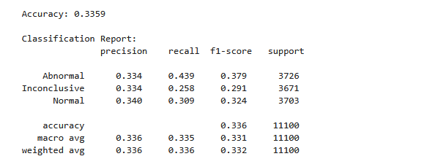
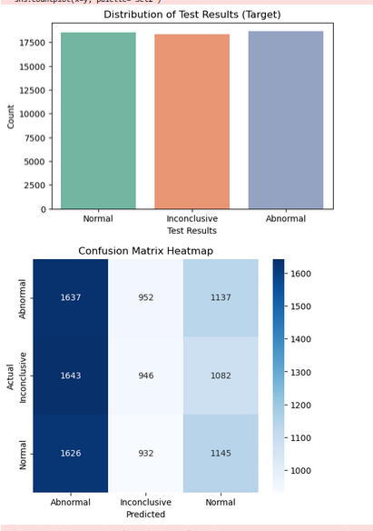

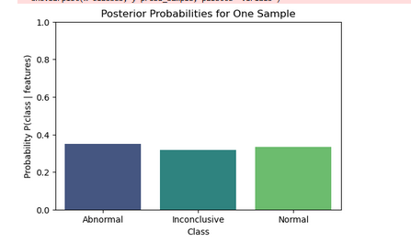

Learnings:
Bayesian learning updates beliefs using Bayes’ Theorem.
It combines prior knowledge with new data.
The result is a new, improved belief (posterior).
It’s useful for learning under uncertainty.
Common in AI, statistics, and decision-making.

